**Topic:**

**Hospital management system**



**Subject:**

**Database Lab**

Submitted by:

Anns Shahzad (2019-CS-601)

Muhammad Hassan Ijaz (2019-CS-617)

Ammar Yasir (2019-CS-604)

Waleed Irfan (2019-CS-611)

**Submitted to:**

**Mr. Faizan Ahmad**

**Department of Computer Science**

**University of Engineering & Technology, Lahore (New Campus)**

**ER Diagram:**

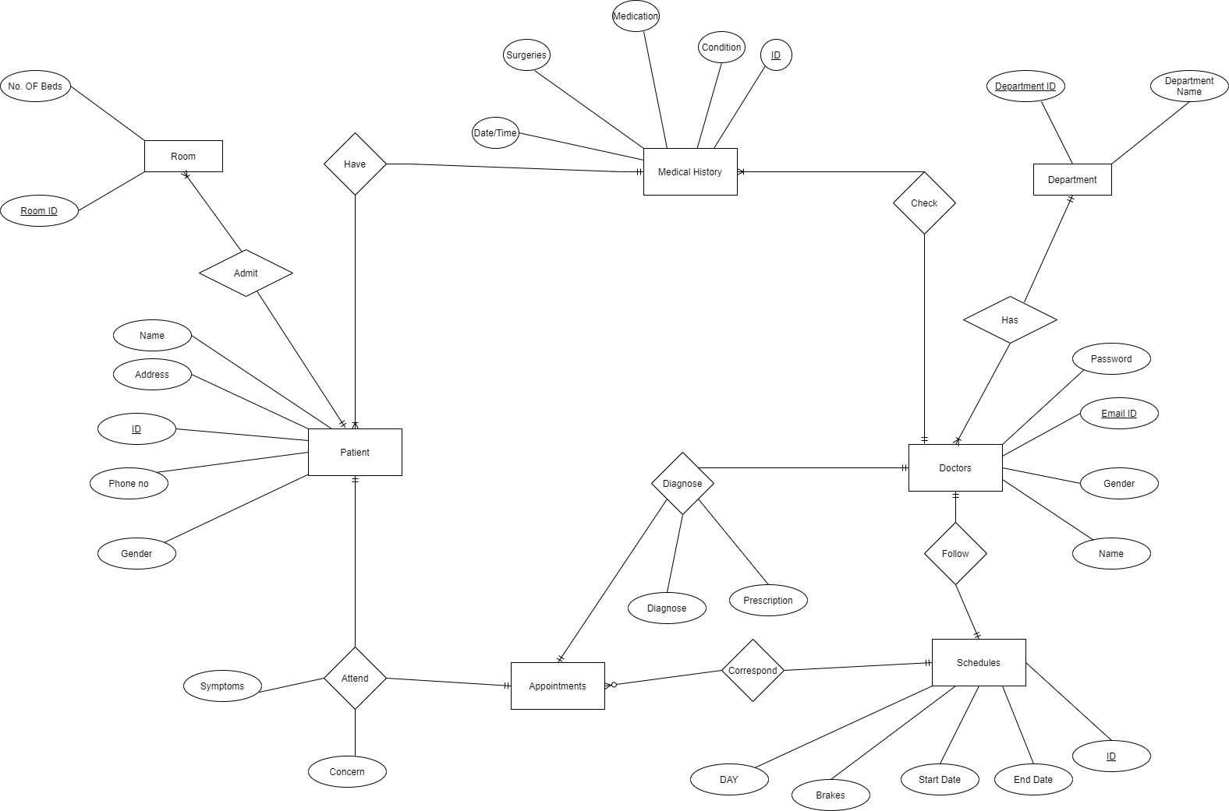

**Relational Schema:**

* **Patient:**

|  |  |  |  |  |
| --- | --- | --- | --- | --- |
| Pat_ID | Password | Name | Address | Gender |

* **Medical History:**

|  |  |  |  |  |  |
| --- | --- | --- | --- | --- | --- |
| ID | Date | Conditions | Surgeries | Medication | DID |

* **Doctor:**

|  |  |  |  |
| --- | --- | --- | --- |
| Doc_ID | Gender | Password | Name |

* **Appointment:**

|  |  |  |  |  |
| --- | --- | --- | --- | --- |
| ID | Date | Start Time | End Time | Status |

* **Room:**

|  |  |
| --- | --- |
| RoomID | No. of beds |

* **Schedule:**

|  |  |  |  |  |
| --- | --- | --- | --- | --- |
| ID | Start Time | End Time | Break time | Day |

* **PatientsFullHistory:**

|  |  |
| --- | --- |
| Patient | History |

* **Theater:**

|  |  |
| --- | --- |
| Theater ID | Theater section |

* **DocHaveSchedule:**

|  |  |
| --- | --- |
| SchedID | Doctor |

* **Department:**

|  |  |
| --- | --- |
| Department ID | Department Name |

* **Nurse:**

|  |  |  |  |
| --- | --- | --- | --- |
| Nurse_ID | Gender | Password | Name |

**Create Tables:**

**Patient Table:**

CREATE TABLE Patient(

Pat_id varchar(50) PRIMARY KEY,

password varchar(30) NOT NULL,

name varchar(50) NOT NULL,

address varchar(60) NOT NULL,

gender VARCHAR(20) NOT NULL

);

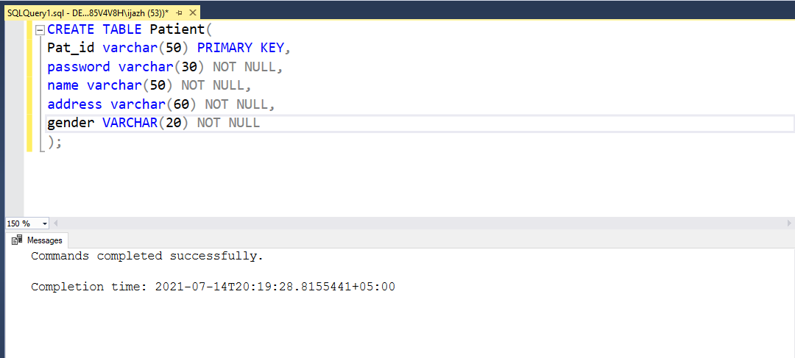

**Doctor Table:**

CREATE TABLE Doctor(

Doc_ID varchar(50) PRIMARY KEY,

gender varchar(20) NOT NULL,

password varchar(30) NOT NULL,

name varchar(50) NOT NULL

);

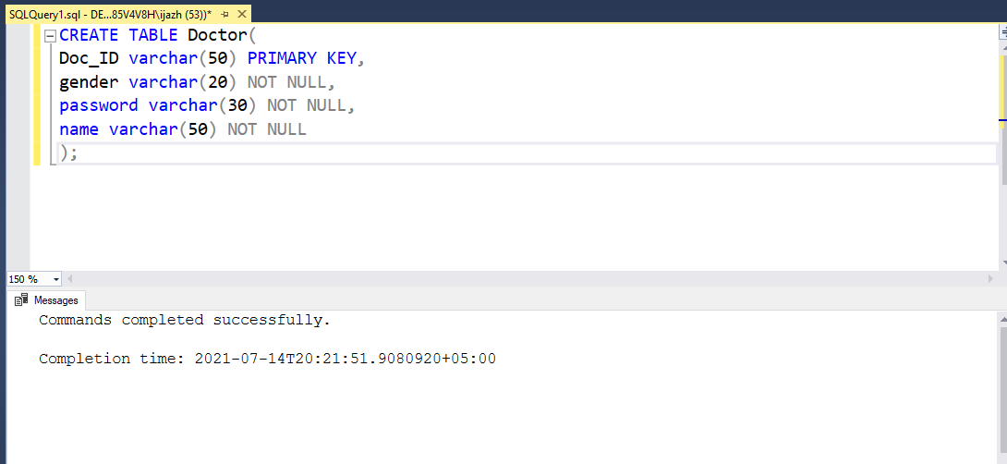

**Nurse Table:**

Create Table Nurse(

nurse_ID varchar(50) PRIMARY KEY,

gender varchar(20) NOT NULL,

password varchar(30) NOT NULL,

name varchar(50) NOT NULL

);

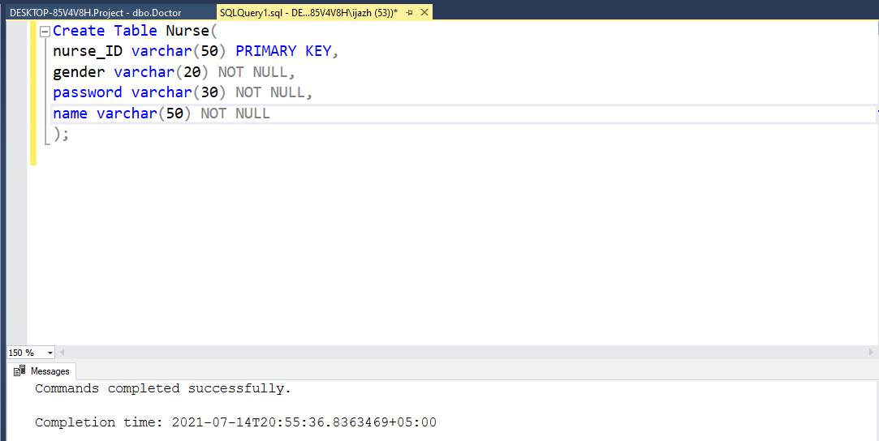

**Medical History Table:**

CREATE TABLE MedicalHistory(

id int PRIMARY KEY,

date DATE NOT NULL,

conditions VARCHAR(100) NOT NULL,

surgeries VARCHAR(100) NOT NULL,

medication VARCHAR(100) NOT NULL

);

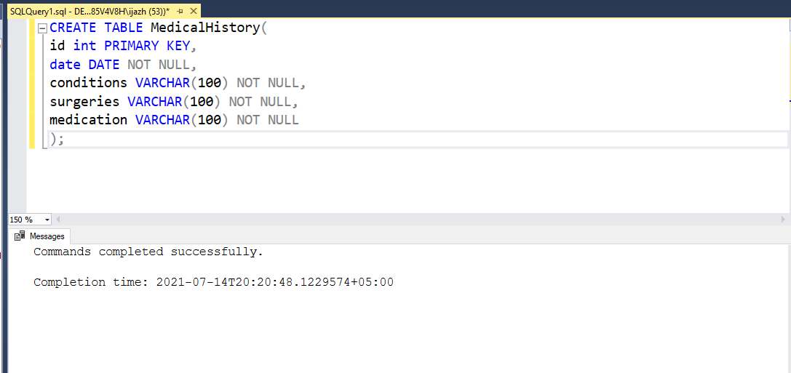

**Appointment Table:**

CREATE TABLE Appointment(

id int PRIMARY KEY,

date DATE NOT NULL,

starttime TIME NOT NULL,

endtime TIME NOT NULL,

status varchar(15) NOT NULL

);

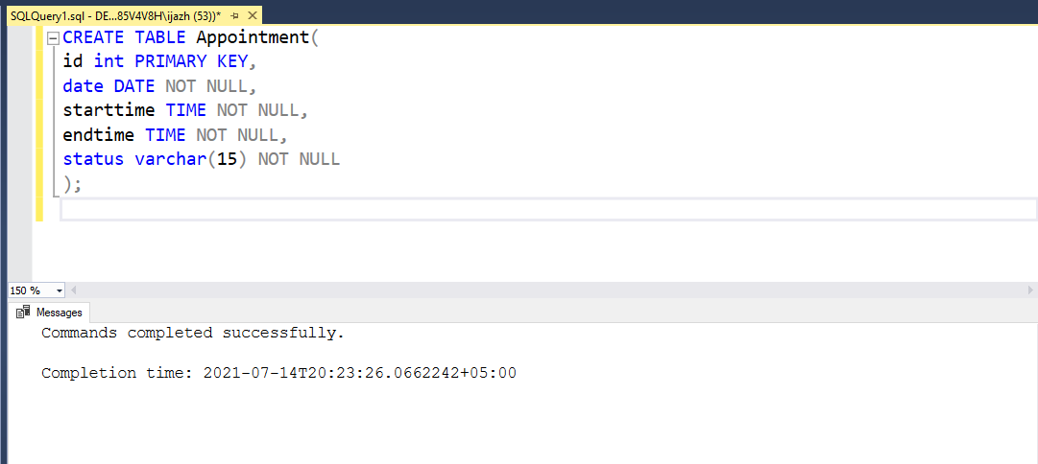

**Room Table:**

CREATE TABLE Room(

Room_ID int primary key,

No_of_beds int not null

);

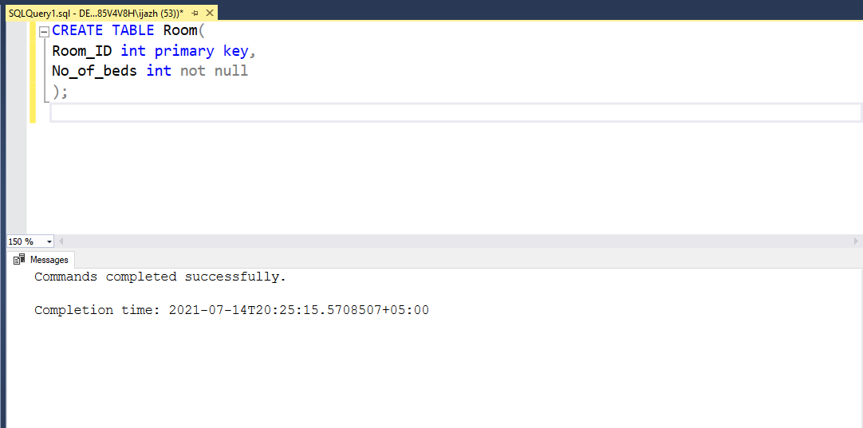

**Schedule Table:**

CREATE TABLE Schedule(

id int Primary key,

starttime TIME NOT NULL,

endtime TIME NOT NULL,

breaktime TIME NOT NULL,

day varchar(20) NOT NULL,

);

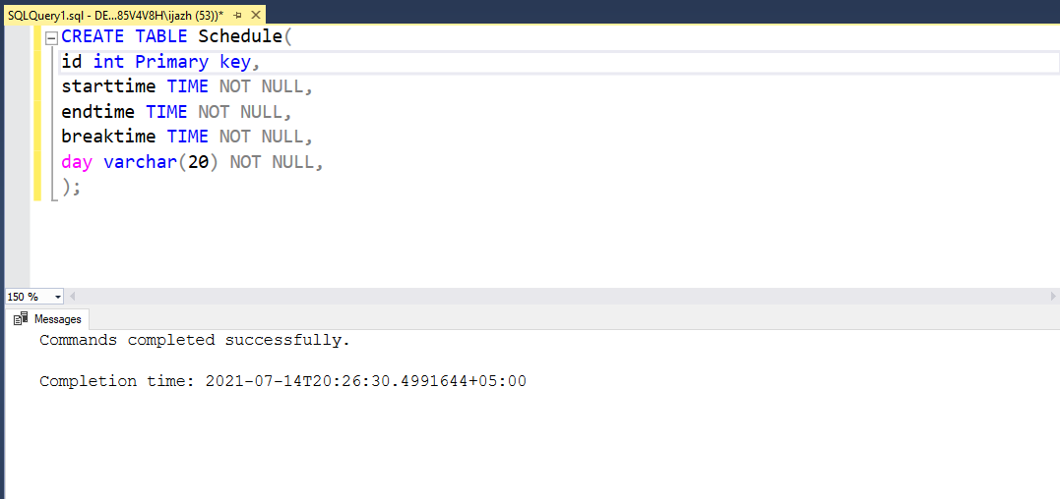

**Patient Fill History:**

CREATE TABLE PatientsFillHistory(

patient varchar(50) NOT NULL,

history int NOT NULL,

FOREIGN KEY (patient) REFERENCES Patient (Pat_ID) ON DELETE CASCADE,

FOREIGN KEY (history) REFERENCES MedicalHistory (id) ON DELETE CASCADE,

PRIMARY KEY (history)

);

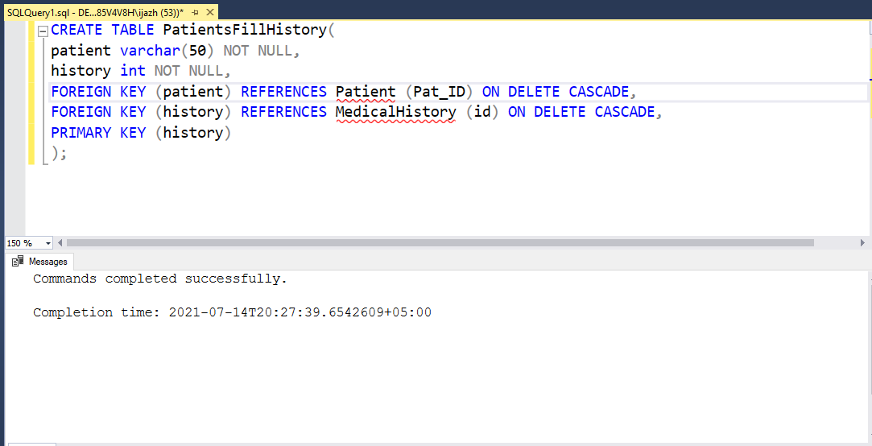

**Theater Table:**

CREATE TABLE Theater(

Theater_ID int Primary key,

Theater_Section varchar(50) not null

);

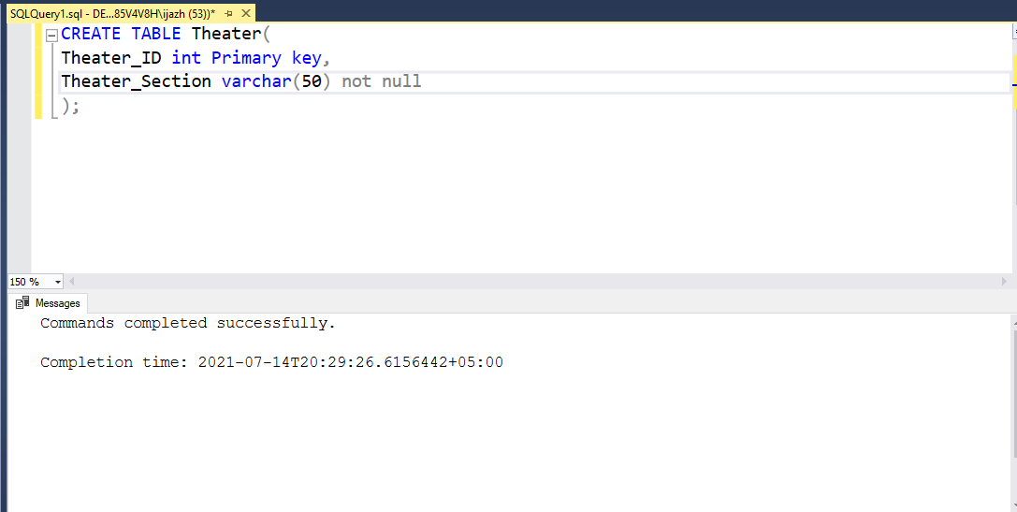

**DocHaveSecudules:**

CREATE TABLE DocsHaveSchedules(

sched int NOT NULL,

doctor varchar(50) NOT NULL,

FOREIGN KEY (sched) REFERENCES Schedule (id) ON DELETE CASCADE,

FOREIGN KEY (doctor) REFERENCES Doctor (Doc_ID) ON DELETE CASCADE,

PRIMARY KEY (sched, doctor)

);

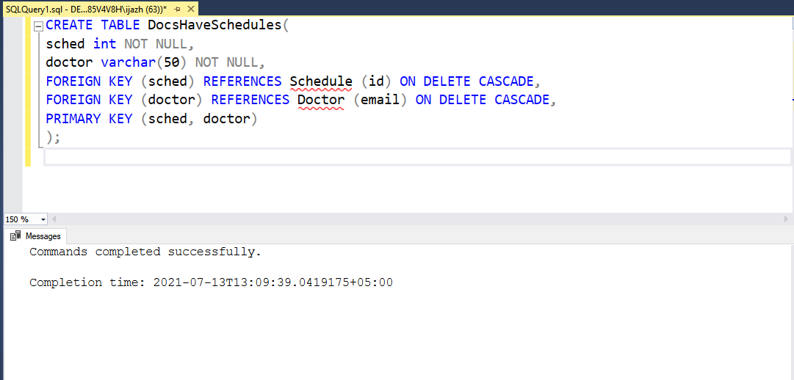

**Department Table:**

CREATE TABLE Department(

Department_ID int primary key,

Department_name varchar(50) not null

);

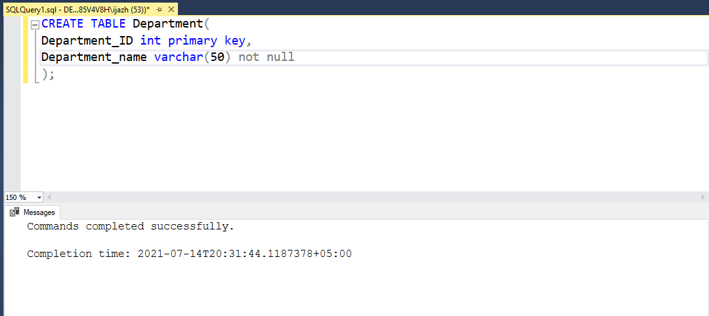

**Insert Queries:**

**Insertion in doctor:**

INSERT INTO Doctor(Doc_ID, gender, password, name)

VALUES

('Doc0', 'male', 'abc12', 'Zain'),

('Doc1', 'Female', 'def34', 'fatima'),

('Doc2', 'male', 'def34', 'hassan'),

('Doc3', 'male', 'def34', 'subhan'),

('Doc4', 'Female', 'def34', 'laiba'),

('Doc5', 'male', 'def34', 'moiz'),

('Doc6', 'male', 'def34', 'osama'),

('Doc7', 'male', 'def34', 'burhan'),

('Doc8', 'male', 'def34', 'ammar'),

('Doc9', 'male', 'def34', 'waleed');

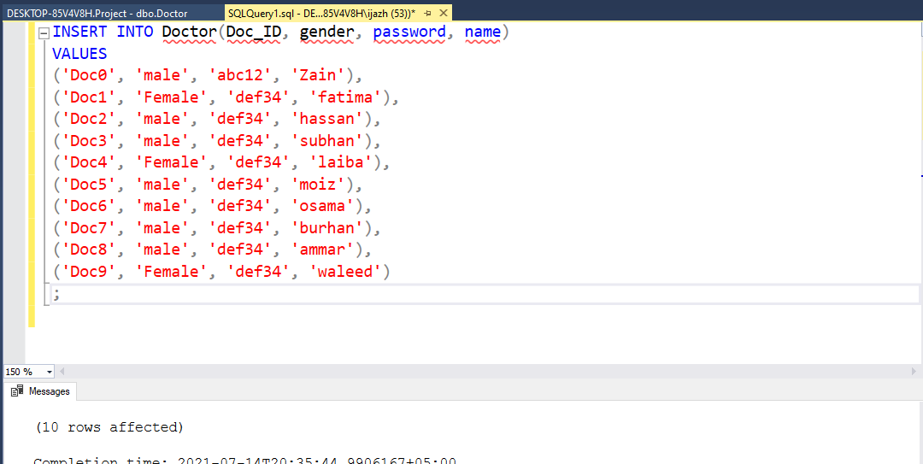

**Insertion in patient:**

INSERT INTO Patient(Pat_ID,password,name,address,gender)

VALUES

('pat123','abc123asd','Hassan','Lahore', 'male'),

('pat456','abc123asd ','Waleed','Lahore', 'male'),

('pat789','abc123asd ','Anss','Lahore', 'male'),

('pat0','abc123asd ','Ammar','Muredkai', 'male'),

('pat1','abc123asd ','hur','Lahore', 'male'),

('pat2','abc123asd ','osama','Lahore', 'male'),

('pat3','abc123asd ','moiz','Lahore', 'male'),

('pat4','abc123asd ','burhan','Lahore', 'male'),

('pat5','abc123asd ','ahad','Lahore', 'male'),

('pat6','abc123asd ','umair','Lahore', 'male');

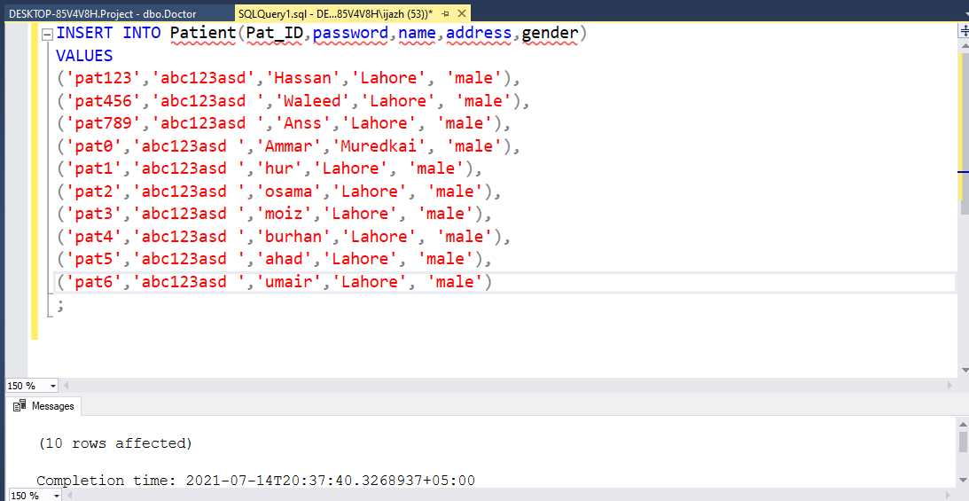

**Insertion in Medical History:**

INSERT INTO MedicalHistory(id,date,conditions,surgeries,medication)

VALUES

(123,'2021-02-01','Pain in abdomen','Heart Surgery','Crocin'),

(456,'2021-03-02','Food Poisoning','none','none'),

(789,'2021-01-19','Body Pain','none','Iodex'),

(0,'2021-04-18','Body Pain','none','Iodex'),

(1,'2021-05-9','Body Pain','none','Iodex'),

(2,'2021-03-10','Body Pain','none','Iodex'),

(3,'2021-08-20','Body Pain','none','Iodex'),

(4,'2021-06-19','Body Pain','none','Iodex'),

(5,'2021-10-16','Body Pain','none','Iodex'),

(6,'2021-12-19','Body Pain','none','Iodex');

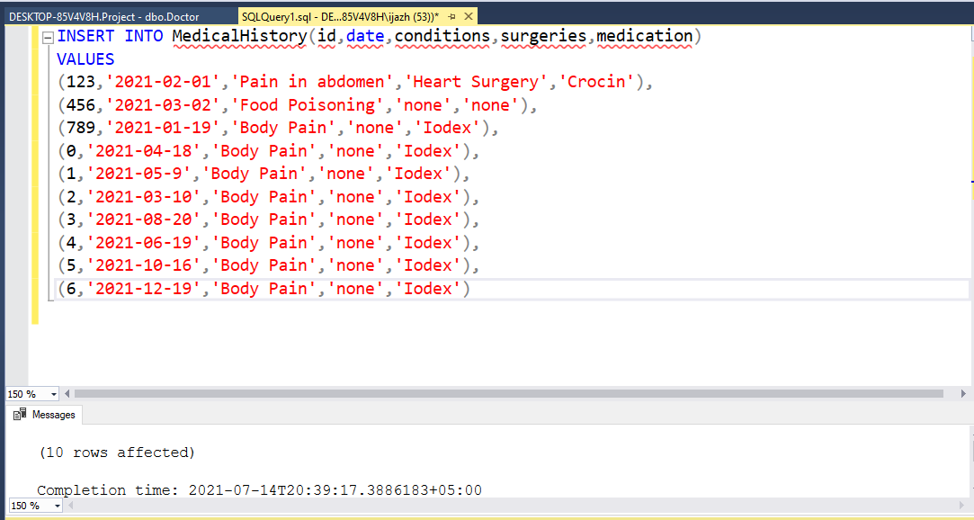

**Insertion in Appointment:**

INSERT INTO Appointment(id,date,starttime,endtime,status)

VALUES

(1, '2021-01-15', '09:00', '10:00', 'Done'),

(2, '2020-01-16', '10:00', '11:00', 'Done'),

(3, '2021-01-18', '14:00', '15:00', 'Done'),

(4, '2021-01-18', '12:00', '13:00', 'Done'),

(5, '2021-01-18', '13:00', '14:00', 'Done'),

(6, '2021-01-18', '15:00', '16:00', 'Done'),

(7, '2021-01-18', '17:00', '18:00', 'Done'),

(8, '2021-01-18', '11:00', '12:00', 'Done'),

(9, '2021-01-18', '21:00', '22:00', 'Done'),

(22, '2021-01-18', '19:00', '20:00', 'Done');

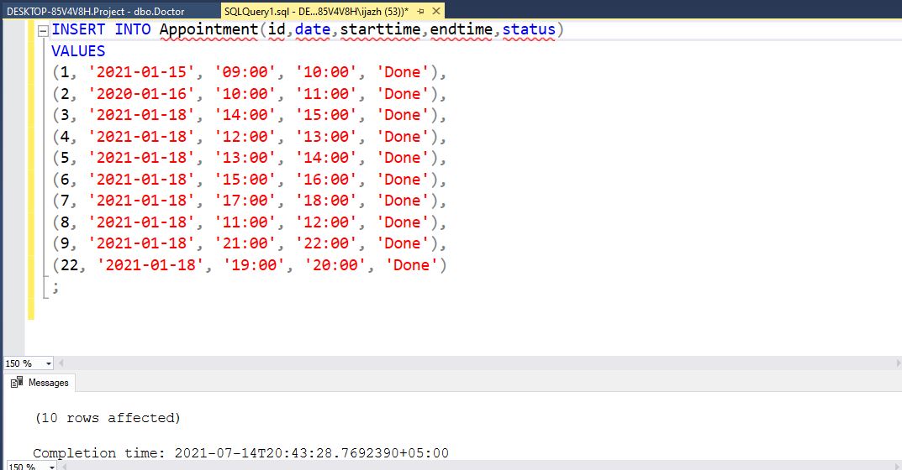

**Insertion in schedule:**

INSERT INTO Schedule(id,starttime,endtime,breaktime,day)

VALUES

(001,'09:00','17:00','12:00','Tuesday'),

(002,'09:00','17:00','12:00','Friday'),

(003,'09:00','17:00','12:00','Saturday'),

(004,'09:00','17:00','12:00','Sunday'),

(005,'09:00','17:00','12:00','Wednesday'),

(006,'09:00','17:00','12:00','Friday'),

(007,'09:00','17:00','12:00','maonday'),

(008,'09:00','17:00','12:00','tuesday'),

(009,'09:00','17:00','12:00','wednesday'),

(010,'09:00','17:00','12:00','Friday');

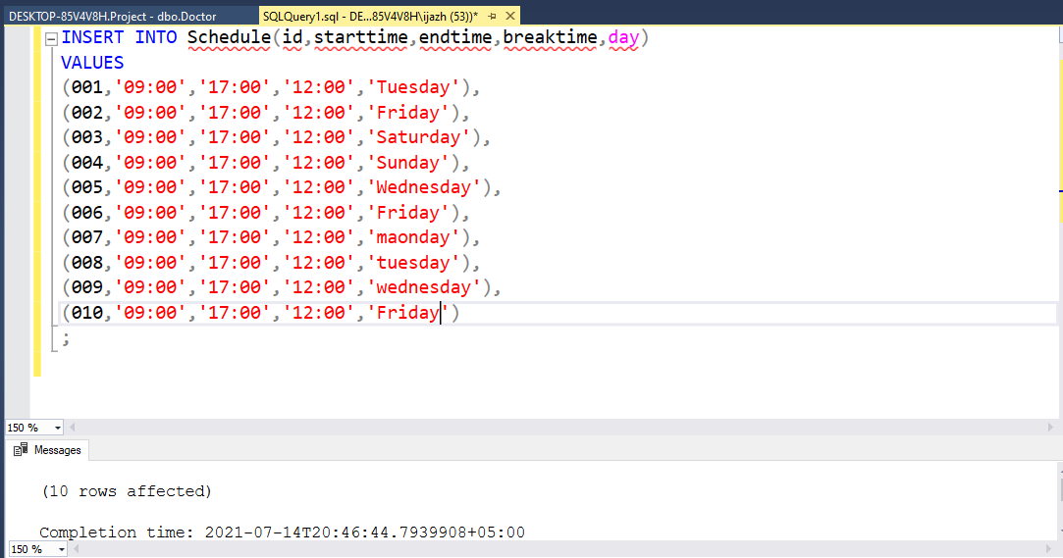

**Insertion in Nurse:**

INSERT INTO Nurse(Nurse_ID, gender, password, name)

VALUES

('nur0', 'male', 'abc12', 'zohaib'),

('nur1', 'Female', 'def34', 'fatima'),

('nur2', 'male', 'def34', 'usman'),

('nur3', 'male', 'def34', 'khizar'),

('nur4', 'Female', 'def34', 'amna'),

('nur5', 'male', 'def34', 'hamza'),

('nur6', 'male', 'def34', 'akram'),

('nur7', 'male', 'def34', 'waheed'),

('nur8', 'male', 'def34', 'babar'),

('nur9', 'Female', 'def34', 'asma');

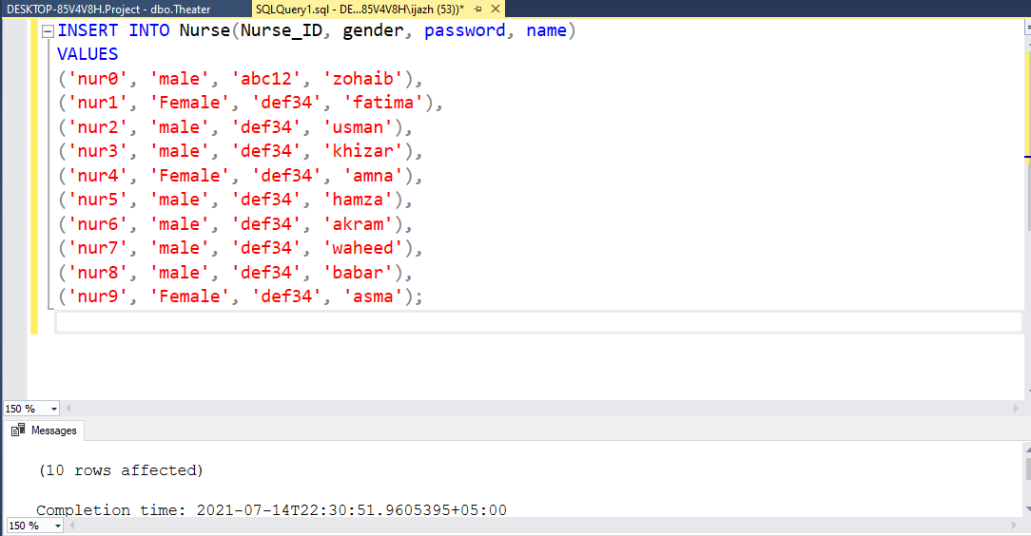

**Insertion in DocHaveSchedules:**

INSERT INTO DocsHaveSchedules(sched,doctor)

VALUES

(001,'Doc0'),

(002,'Doc1'),

(003,'Doc2'),

(004,'Doc3'),

(005,'Doc4'),

(006,'Doc5'),

(007,'Doc6'),

(008,'Doc7'),

(009,'Doc8'),

(010,'Doc9');

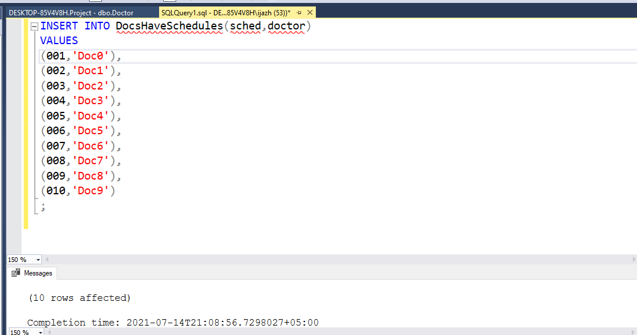

**Insertion in PatientFullHistory:**

INSERT INTO PatientsFillHistory(patient,history)

VALUES

('pat123', 123),

('pat456', 456),

('pat789', 789),

('pat0', 0),

('pat1', 1),

('pat2', 2),

('pat3', 3),

('pat4', 4),

('pat5', 5),

('pat6', 6);

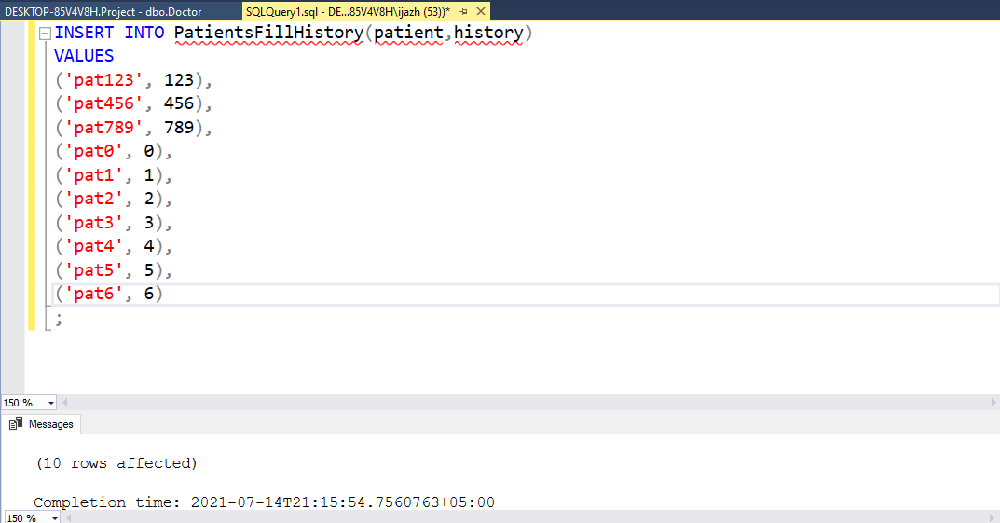

**Insertion in Department:**

INSERT INTO Department(Department_ID,Department_Name)

VALUES

(01, 'Brain cancer'),

(02, 'orthopedic'),

(03, 'Neuro'),

(04, 'cardiology'),

(05, 'emrgency'),

(06, 'children ward'),

(07, 'dental ward'),

(08, 'stomach ward'),

(09, 'eyes ward'),

(10, 'gynochologist ward');

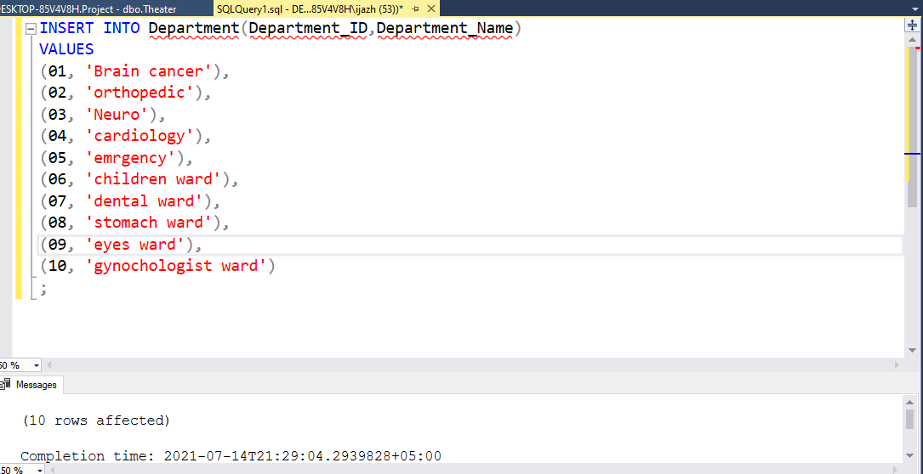

**Insertion in Theatre:**

INSERT INTO theater(Theater_ID,Theater_Section)

VALUES

(01, 'Brain cancer'),

(02, 'orthopedic'),

(03, 'Neuro'),

(04, 'heart Attack'),

(05, 'emrgency'),

(06, 'children section'),

(07, 'dental section'),

(08, 'Kidney operation'),

(09, 'eye ward'),

(10, 'gynachologist section');

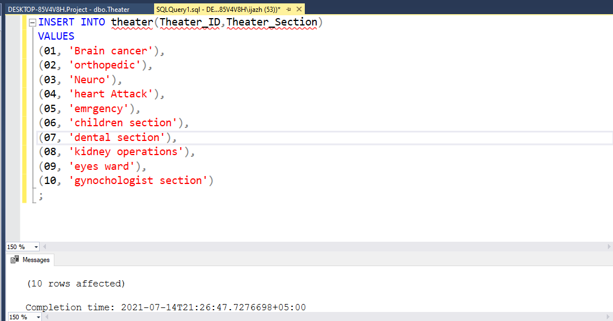

**Insertion in Room:**

INSERT INTO Room(Room_id,No_of_beds)

VALUES

(001,10 ),

(002,15 ),

(003,20 ),

(004,30 ),

(005,3 ),

(006,14),

(007,17),

(008,19 ),

(009,20 ),

(010,18 );

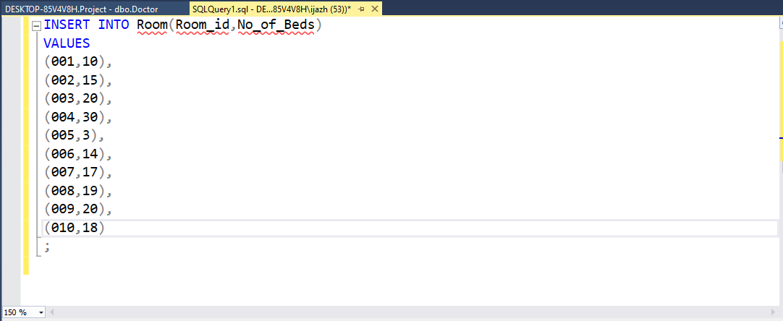

**DDL Commands**

**Select Query:**

* When you must check what is in the table.
  + Select * from Patient
* When you must check the values from the table on specific condition.
  + Select *

from Patient

where email = '101@fgh.com'

**Alter Query:**

* This command is used to alter the table.
  + Alter Table patient

add phone_no int;

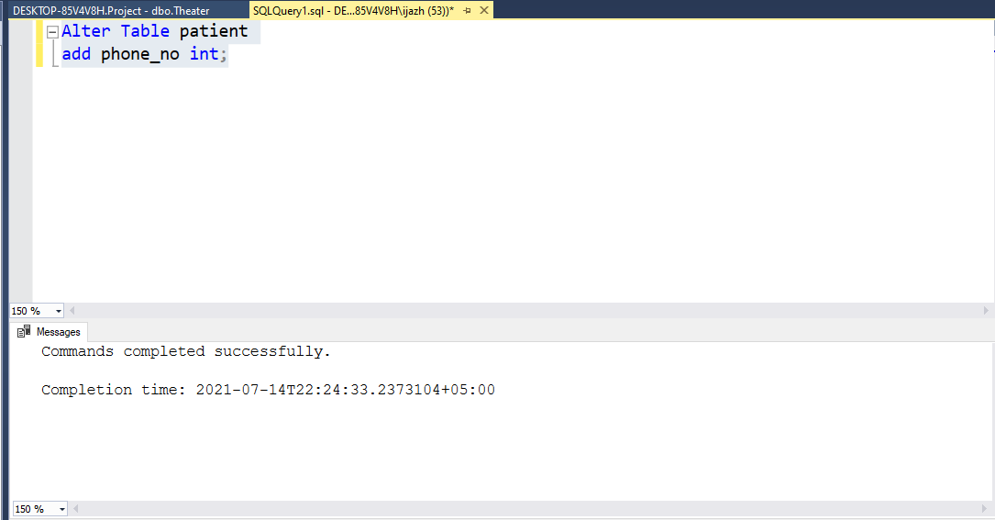

**Truncate Query:**

* This command is used to delete all the rows from the table.
  + Truncate table Nurse

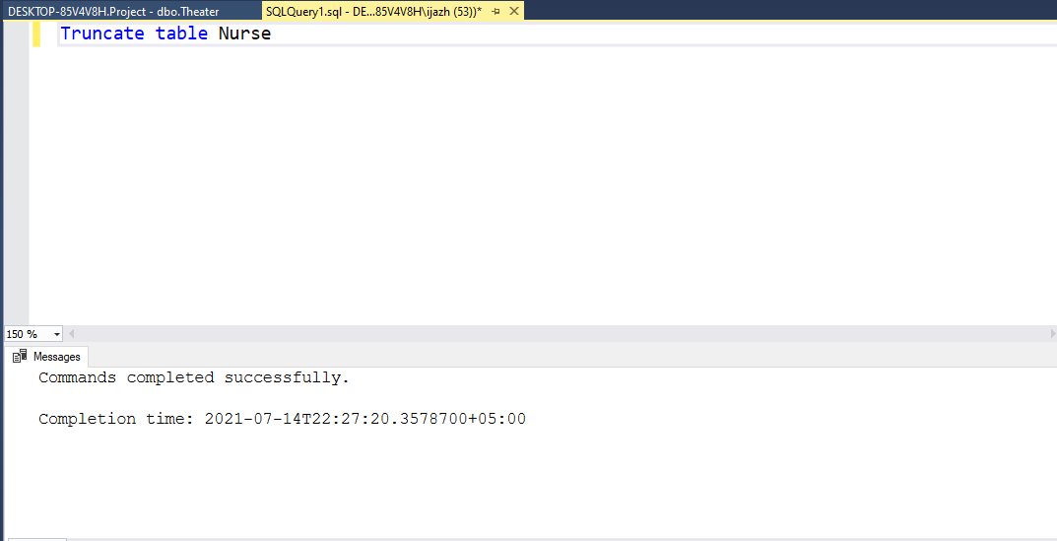

**Drop Query:**

* This command is used to delete both the structure and record stored in the table.
  + Drop table Nurse

**DML Commands**

**Update Query:**

* This command is used to update the table.
  + Update patient

set name='ghulam hur',address='muredkie'

where Pat_id='pat1';

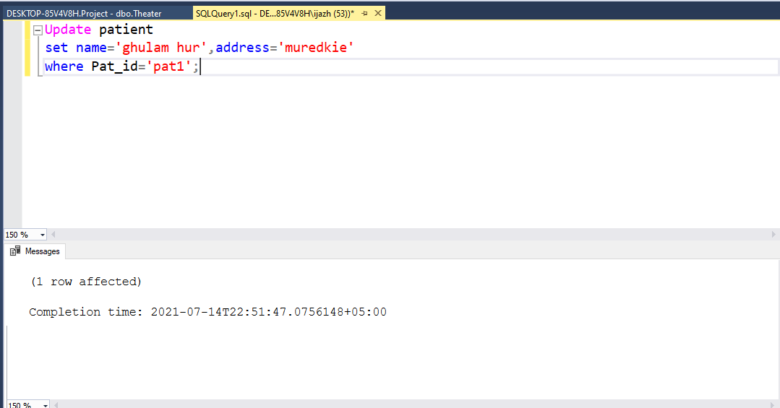

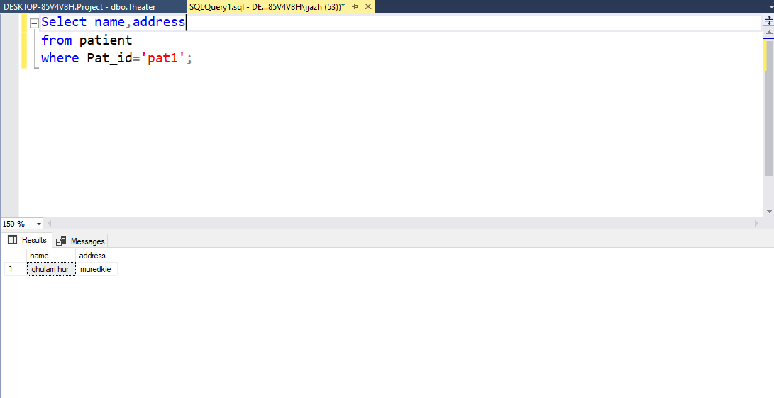

**Delete Query:**

* This command is used to delete a column or row from the table
  + Delete From Room

where Room_ID=009;

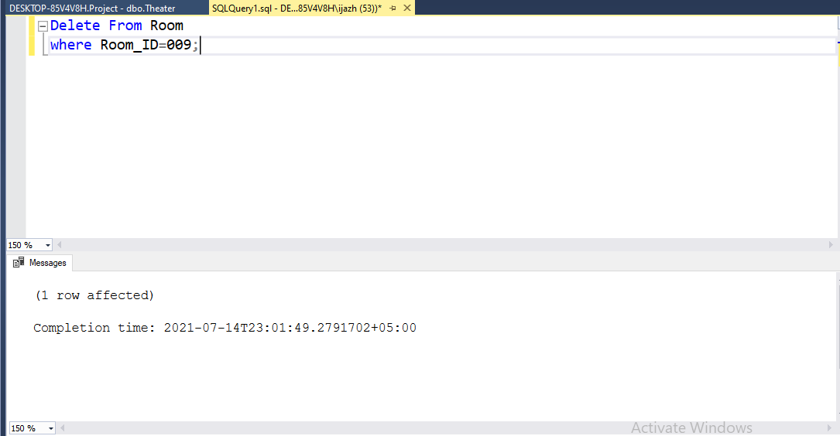

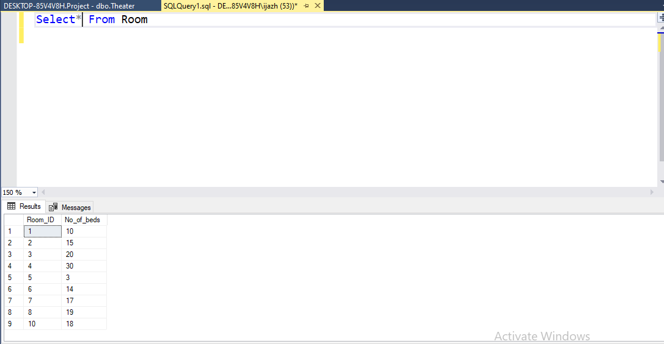

**Case Studies:**

**Display The info of patient along his patientfullHistory and also the doc info along his medical history.**

Select P.name,P.Pat_id,D.Doc_ID,MH.medication

from (Patient as P inner join PatientsFillHistory as PH on P.Pat_id=PH.patient)inner join MedicalHistory as MH on MH.id=PH.history inner join Doctor as D on D.Doc_ID=MH.DID

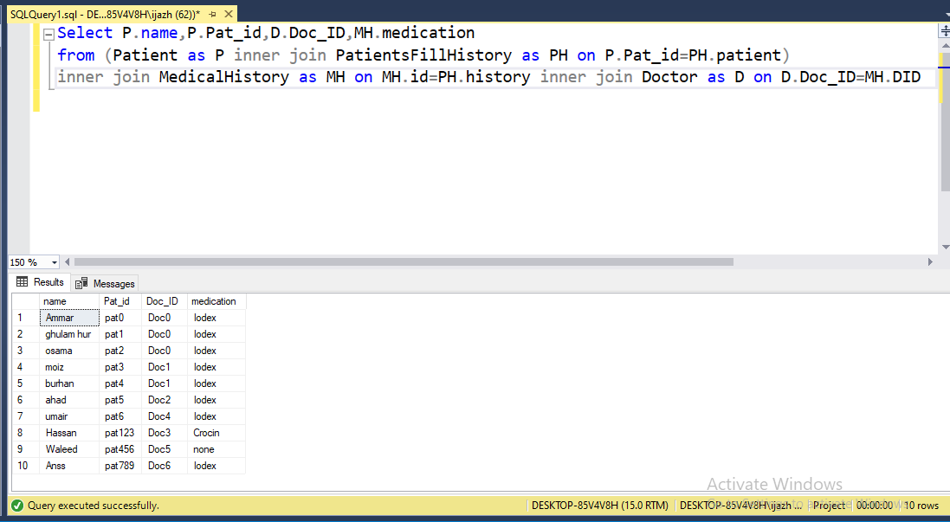

**Display The information of doctor along his Doc Schedule and information of patient check by the doctor.**

Select D.name ,DH.sched,P.name,P.gender

from (Doctor as D left join DocsHaveSchedules as DH on D.Doc_ID=DH.doctor)

left join MedicalHistory as MH on MH.DID=D.Doc_ID

left join PatientsFillHistory as PH on PH.History=MH.id

left join Patient as P on P.Pat_id= PH.patient

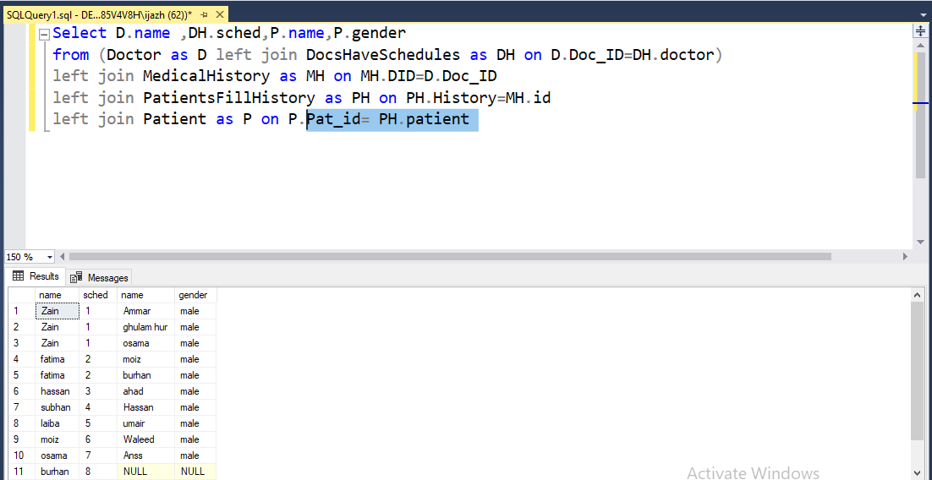

**Display the information od doctor along his DochaveSechudule and the info of schedule of doctors.**

Select *

from (Doctor as D right join DocsHaveSchedules as DH on D.Doc_ID=DH.doctor)

right join Schedule AS S on S.id=DH.sched

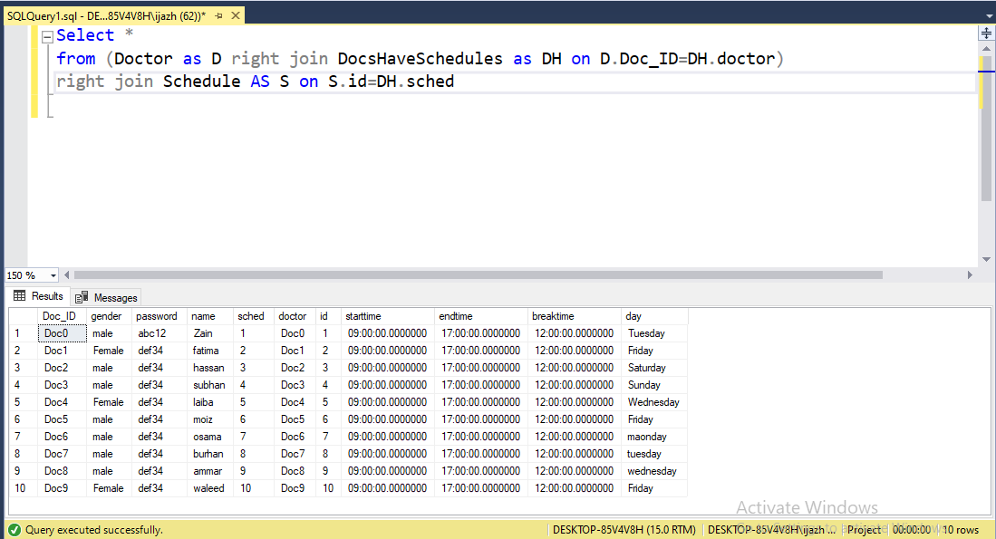

**Display the name of the doctors and the count how many patients checked by the Doctor.**

Select D.Name,count(*) as 'Patients Checked'

from Doctor as D

where Doc_ID in (Select MH.DID

From MedicalHistory as MH

where MH.id in

(select PH.History from PatientsFillHistory as PH,Patient as P where PH.patient=P.Pat_id))

group by D.Name

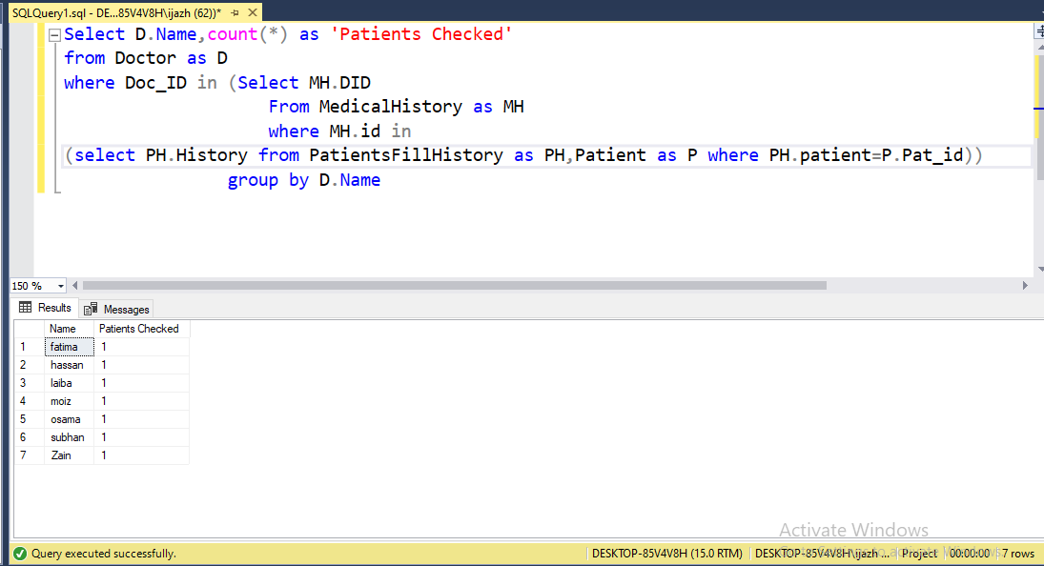

**Display the doctor id who have schedule according to doctor ID**.

Select *

from DocsHaveSchedules as DH

where DH.doctor in(select D.Doc_ID from Doctor as D

where DH.doctor=D.Doc_ID)

